Policy Debate Topic-2015-16
Resolved: The United States federal government should substantially curtail its domestic surveillance.

Novice Topic Limits (for first year students)
- Government Surveillance Drones

- Pass U.S. Senate Bill 356 (Electronic Communication Privacy Act Amendments Act of 2015)

- Curtail the Physical Surveillance of Muslim Communities

National Speech and Debate Association (formerly the National Forensic League)
The NSDA is our national speech organization. Information about the organization can be found at http://www.speechanddebate.org/. Students earn points toward degrees every time they compete. Degrees range from merit (25 points) to premier distinction (1500 points). Individual degrees will be awarded at the annual speech and debate banquet April 30 in the Bobcat Commons. Students must be members of NSDA to qualify for the national tournament (this year in Salt Lake City, UT). Lifetime membership dues are $20. To avoid major fund raising, we are asking students to pay their own dues. Please see Ms. Pies if this is a hardship.

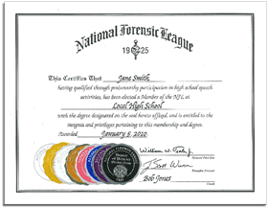

Judging
BHS will be hosting the annual Bell Debate tournament Dec. 18-19 as well as the national qualifier Feb. 26-27. We welcome your involvement as a public forum judge (or other division if you have a debate background).

